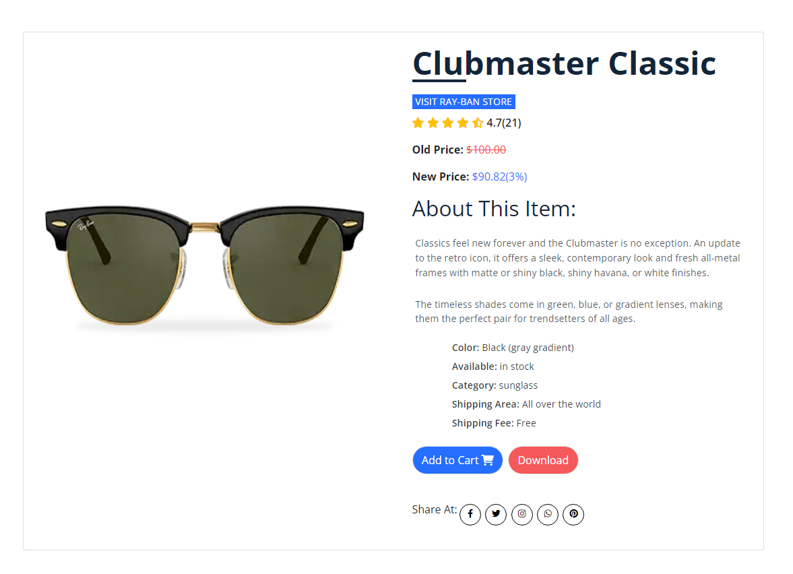
Product Details
Ray-Ban Clubmaster Classic sunglasses are retro and timeless. Inspired by the 50’s, the unmistakable design of the Clubmaster Classic is worn by cultural intellectuals, those who lead the changed tomorrow.
Choose the iconic Clubmaster Classic sunglasses design in black or brown frames with a crystal green lens treatment. While wearing Ray-Ban RB3016 Clubmaster Classic design, you’ll always make a statement.

